8th Grade Fall Semester Exam Review Part 1 - 2014
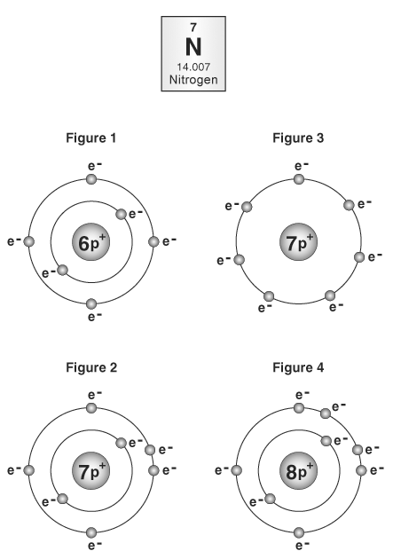
1. The diagram shows the box of the periodic table that represents nitrogen. Which atomic drawing correctly shows a representation of the electrons and protons for the structure of nitrogen?
A. Figure 1
B. Figure 2
C. Figure 3
D. Figure 4
2. A neon atom contains 10 protons, 10 neutrons, and 10 electrons. What is its mass number?
A. 30
B. 20
C. 10
D. 5
3. Which statement best describes electrons in an atom?
A. They move along well-defined orbits within the nucleus.
B. They move along undefined paths within the nucleus.
C. They move along well-defined orbits outside the nucleus.
D. They move along undefined paths outside the nucleus.
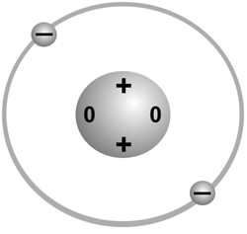
4. The diagram shows a model of a helium atom. How could you change the model so that it would represent a different element?
A. take away an electron
B. take away the nucleus
C. add an extra proton
D. add an extra neutron
5. The Bohr model of an atom is not an exact model of a real atom because
A. the protons are negatively charged.
B. the nucleus of a real atom is much smaller than a Bohr model nucleus.
C. the electrons are larger in a real atom than a Bohr model.
D. the neutrons are not neutral.
6. A model of an atom has 6 neutrons, 5 protons, and 6 electrons. Which description of the atom is correct?
A. Its mass number if 6.
B. It has a negative charge.
C. Its atomic number is 12.
D. It has 12 particles in its nucleus.
7. What is an electron?
A. positively charged particle in the nucleus of an atom
B. negatively charged particle that orbits around the nucleus of an atom
C. neutral particle in the nucleus of an atom
D. negatively charged particle in the nucleus of an atom
8. What is a valence electron?
A. an electron in the innermost energy level of an atom
B. an electron that moves to a higher energy level
C. an electron in the outermost energy level of an atom
D. an electron that moves into the atom's nucleus
9. What is the difference between an element and a compound?
A. An element is made of only one kind of atom. A compound is made of two or more elements that are chemically combined.
B. An element is made of two or more elements that are chemically combined. A compound is made of only one kind of atom.
C. An element is always a single atom. A compound is always two atoms.
D. An element is a single atom. A compound is a molecule made of identical atoms.
10.
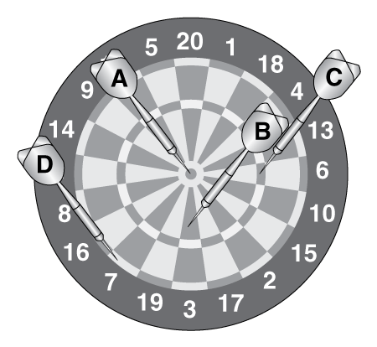
Imagine that this dartboard is an atom. Which dart indicates where the valence electrons are located?
A. Dart A
B. Dart B
C. Dart C
D. Dart D
11. You make yourself a piece of toast before leaving for school in the morning. What energy transformations are involved in making a piece of toast?
A. Electrical energy is transformed into heat energy and some light energy.
B. Heat energy is transformed into electrical energy.
C. Heat and light energy are transformed into electrical energy.
D. Chemical energy is transformed into electrical energy.
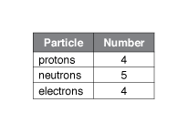
12. The table shows the number of subatomic particles in a beryllium atom. How are atoms of lithium different?
A. The number of electrons must be different, but the number of protons and neutrons can be the same.
B. The number of protons must be different, but the number of neutrons and electrons can be the same.
C. The number of neutrons must be different, but the number of protons and electrons can be the same.
D. The number of electrons and neutrons must be different, but the number of protons can be the same.
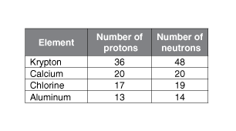
13. The table shows the number of protons and neutrons for atoms of four elements. Which statement is true?
A. The atomic number of krypton is 36.
B. The mass number of calcium is 20.
C. The number of neutrons of chlorine is always 19.
D. A charged atom of aluminum has 13 electrons.
14. The atomic number of an atom is equal to
A. the number of protons in the atom.
B. the number of protons and neutrons in the atom.
C. the number of protons and electrons in the atom.
D. the number of protons, neutrons, and electrons in the atom.
15. The equation shown is a summary of photosynthesis.
CO₂ + H₂O → C₆H₁₂O₆ + O₂ What are the products of the reaction?
A. CO₂ + H₂O
B. C₆H₁₂O₆ + O₂
C. H₂O + O₂
D. C₆H₁₂O₆ + CO₂
16. Which of the following is a chemical property of a substance?
A. ability to dissolve in water
B. melting point
C. shape
D. ability to burn
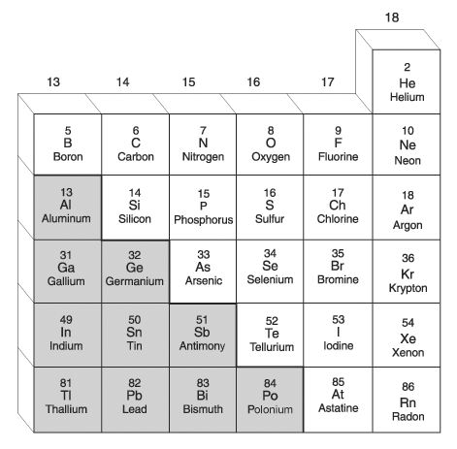
17. A section of the Periodic Table of Elements is shown. For this part of the table, the elements that are sometimes called metalloids include —
A. Al, Ge, Sb, Po
B. Si, As, Te, At
C. He, Ne, Ar, Kr, Xe, Rn
D. Al, Si, Ge, As, Sb, Te
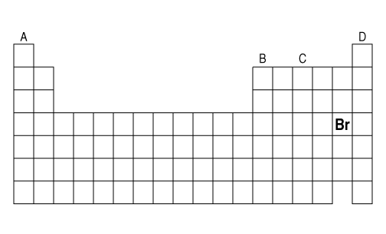
18. The picture shows the placement of the element bromine (Br) on the periodic table. Bromine is a nonmetal that forms compounds with other elements and has a low electrical conductivity. Which column in the picture would have other elements with these properties?
A. column A
B. column B
C. column C
D. column D
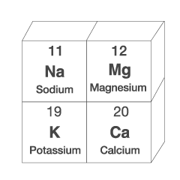
19. The picture shows part of the periodic table of elements. Which two elements shown in the picture would you expect to have properties that are the most similar?
A. sodium and magnesium
B. sodium and calcium
C. magnesium and calcium
D. magnesium and potassium
20. Lithium and sodium are both in column 1 on the periodic table. Because they are in the same column, what can you conclude about these elements?
A. They have the same number of protons.
B. They have the same state of matter at room temperature.
C. The ratio of their protons to neutrons is the same.
D. They have similar chemical properties.
21. Why are recently discovered elements always placed at the bottom of the periodic table?
A. They have the greatest number of protons.
B. Elements are listed in the order in which they are discovered.
C. There is no room to place the elements higher on the periodic table.
D. They are all members of the lanthanide or actinide series.
22. Fluorine is a halogen element, in group 17 on the periodic table. Where would you expect elements that most easily form compounds with fluorine to be located on the periodic table?
A. group 1
B. group 7
C. group 16
D. group 18
23. A scientist has a beaker containing a gas. The gas is not hydrogen, but it easily forms compounds with other elements. Where would you expect this gas to be listed on the periodic table?
A. on left side of the table
B. along the stair-step line on the table
C. near the top, right of the table
D. in group 18, the noble gases
24. The elements that are located along the stair-step line of the periodic table are
A. metals.
B. metalloids.
C. nonmetals.
D. noble gases.
25. Part of the periodic table is shown here. The elements shown in gray are
A. metals.
B. metalloids.
C. nonmetals.
D. noble gases.

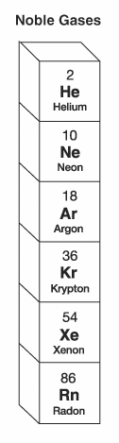Final Exam 8th Grade Science Review Part 2
1. A column of the periodic table is shown to the right. What property do these elements have in common?
A. They are nonreactive.
B. They are metals.
C. They only exist in nature as part of compounds.
D. They can easily lose their outermost electrons.
2. What determines the atomic number of an element?
A. the number of electrons surrounding the nucleus
B. the number of protons in the nucleus
C. the number of neutrons in the nucleus
D. the number of protons and neutrons in the nucleus
3. The formula for ammonium chloride, a substance in batteries, is NH₄Cl. How many atoms are there in each unit of ammonium chloride?
A. 3
B. 4
C. 5
D. 6
4. Potassium nitrate is a compound used in some fertilizers. Its chemical formula is KNO₃. How many atoms are in each unit of potassium nitrate?
A. 2
B. 3
C. 5
D. 9
5. When two substances react chemically, a new substance is formed. This new substance is a(n) —
A. atom
B. mixture
C. solution
D. compound

6.
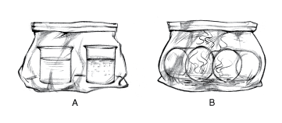
Look at the pictures above. A shows the bag before the vinegar and baking soda are mixed together, and B shows it after they are mixed together. In which picture do the contents of the bag have the greater mass?
A. The mass is greater in A—before they are mixed.
B. The mass is greater in B—after they are mixed.
C. The mass is the same in both.
D. The mass depends on the temperature.
7. Which equation is correctly balanced?
A. KClO₃ → 2KCl + 3O₂
B. 2KClO₃ → KCl + 3O₂
C. 2KClO₃ → 2KCl + 3O₂
D. 2KClO₃ → 3KCl + 2O₂
8. A home heating system uses oil to operate. What energy transformations take place when an oil heating system is in use?
A. Light energy is changed into chemical energy.
B. Heat energy is changed into chemical energy.
C. Electrical energy is changed into heat energy.
D. Chemical energy is changed into heat energy.
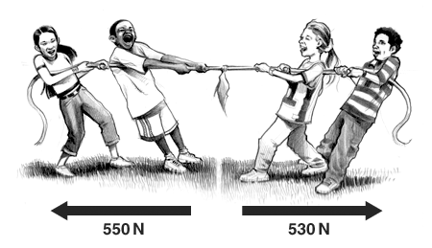
9. The illustration shows two groups of children having a tug of war. The children on the left are exerting a force of 550 Newtons (N) to the left. The children on the right are exerting a force of 530 Newtons (N) to the right. How large, and in what direction, is the net force acting on the rope?
A. 20 N to the right
B. 20 N to the left
C. 1,080 N to the right
D. 1,080 N to the left
10. The action-reaction principle best describes which of Newton's laws of motion?
A. First Law of Motion
B. Second Law of Motion
C. Third Law of Motion
D. Law of universal gravitation
11. When a car suddenly stops moving, its passengers continue moving forward due to
A. pressure.
B. gravity.
C. inertia.
D. friction.

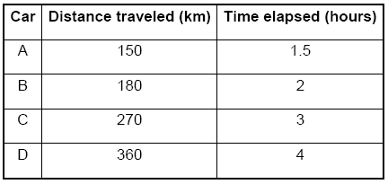
12. What was the average speed of car A?
A. 75 km per hour
B. 100 km per hour
C. 150 km per hour
D. 225 km per hour
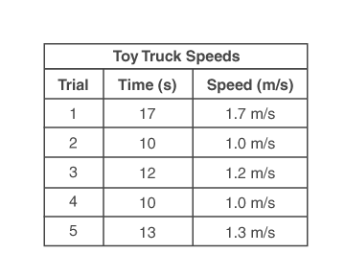
13. In which trial did the toy truck travel the greatest distance?
A. trial 1
B. trial 2
C. trial 3
D. trial 4

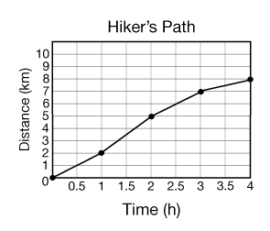
14. Using the graph shown here, what can you determine about the hiker's motion?
A. She moved to the northeast throughout the hike.
B. She moved at a variable speed.
C. the location of the hiker's starting and ending points
D. the reference point to which the hiker's position is being compared
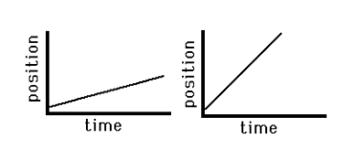
15. Assume that the labels on the axes of these graphs are identical. What can you determine using the graphs?
A. The objects moved in different directions.
B. One object moved a greater distance than the other.
C. Both objects started at the same reference point.
D. The ending position of the objects is the same.

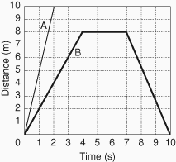
16. The graph shows the motion of two objects. After 1 second of motion, how much more distance had object A moved than object B?
A. 1 meter
B. 2 meters
C. 3 meters
D. 5 meters
17. Suppose it takes 5,500 N to accelerate a car at a rate of 10 m/s². What is the mass of the car?
A. 55,000 kg
B. 5,500 kg
C. 550 kg
D. 5,510 kg
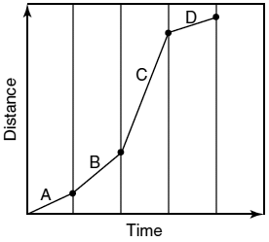
18. Which segment of the line on the graph represents the time period when the object had the greatest average speed?
A. segment A
B. segment B
C. segment C
D. segment D

19.
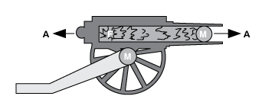
To fire a cannon, soldiers first placed an explosive 'charge' into the cannon and then put in a cannon ball. When they lit the charge, the cannonball was propelled out the open end of the cannon. It would fly into the distance toward its target, which might be a kilometer away. At the same time, the cannon itself would move backward a short distance of just a meter or so.
Which of the following best explains why the cannonball and the cannon moved in opposite directions?
A. The force of the explosion
B. The slope of the ground where the cannon is positioned
C. The law of action-reaction
D. The law of inertia
20. Which stars are the oldest in the universe?
A. red giants
B. white dwarfs
C. red dwarfs
D. massive blue stars

21. On a traditional Hertzsprung-Russell diagram, the stars shown on the left side are blue, while those on the right are red. This indicates that —
A. the stars on the right are farthest from Earth
B. the stars on the left are brightest
C. the stars on the right are hottest
D. the stars on the left are hottest
22. A cloud of gas and dust in interstellar space is called a(n) —
A. star
B. galaxy
C. nebula
D. asteroid belt
23. What is the Sun?
A. It is a star.
B. It is a galaxy.
C. It is a planet.
D. It is a meteoroid.
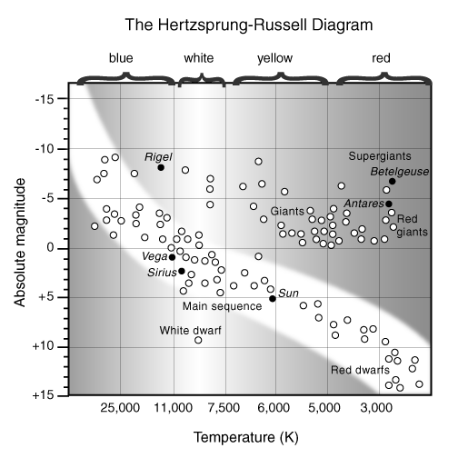
24. Look at the diagram. From the diagram, what can you tell about the star Vega in comparison to the Sun?
A. Vega is much smaller and dimmer than the Sun.
B. Vega is much rounder and warmer than the Sun.
C. Vega is much hotter and brighter than the Sun.
D. Vega is further along in its life cycle than the Sun.
25. Distances between stars are most often measured in —
A. light years
B. kilometers
C. meters
D. wavelengths

